User Manual v1.0

EWI Report

1. Open MySQL Workbench by double clicking on the below icon on Desktop

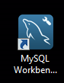

1. Click on OMS_BOB_SC icon

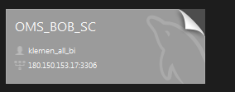

1. Click on File>Open SQL Script and navigate to folder where you SQL scripts are stored, i.e. C:\Users\Finance\Desktop\SAP Reconciliation\SQL Scripts
2. Double click file <<2 Reconciliation Extract – OMS Accounting.sql>>
3. Update the information in green to reflect the correct country 2 letter abbreviation and the dates for the period. Note that the end date should be the start date of the next period rather than last date of previous period.

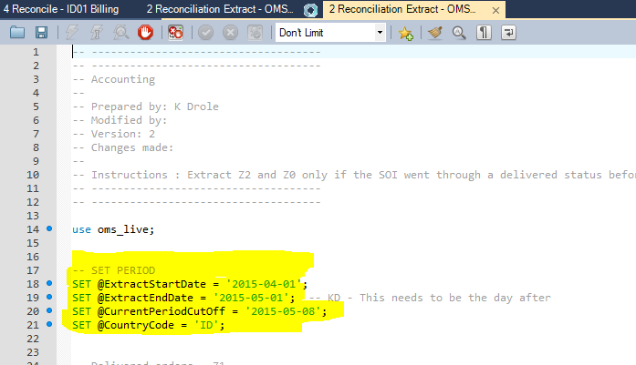

1. Execute the script by clicking the lightning icon highlighted below

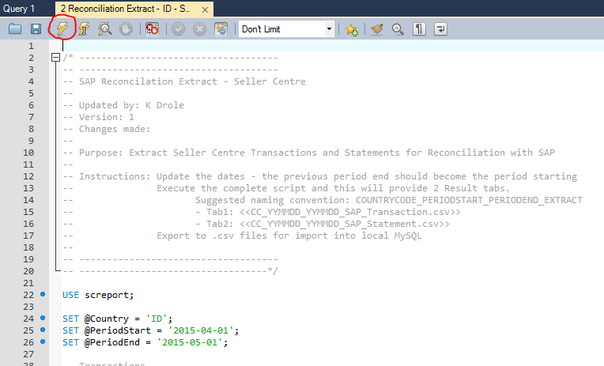

1. Leave the system to run. You will know it is finished once the last row of the Output window does not say Running or Fetching anymore.

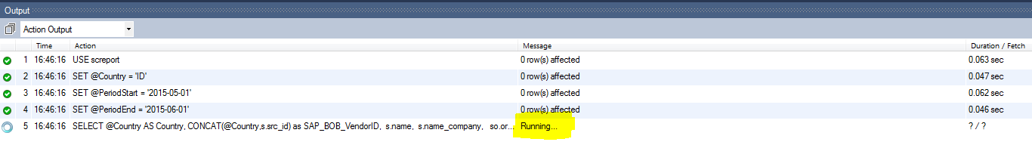

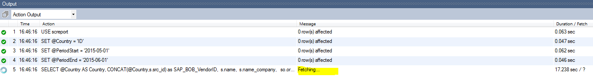

Note that this may take some time. Once done, you should see the number of rows returned in the last row. You will have 4 tabs displayed in the middle results window.